# Tourplan JS Directives

|  |  |
| --- | --- |
| components |  |
| tpbutton |  |
| tpcheckbox |  |
| tpcode |  |
| tpcolourpicker |  |
| tpcombo |  |
| tpdate |  |
| tpdescription |  |
| tpdisablebackspacenavigation |  |
| tpdropdown |  |
| tpeditor |  |
| tpenum |  |
| tpgrid |  |
| tpgridold |  |
| tpgroup |  |
| tplabel |  |
| tplist |  |
| tpmodal |  |
| tpmultilist |  |
| tpnav |  |
| tpnumber |  |
| tpplain |  |
| tpradio |  |
| tpselectdropdown |  |
| tpselectgroup |  |
| tpselectiongrid |  |
| tpselectlist |  |
| tpselectlistscroll |  |
| tptabs |  |
| tptextarea |  |
| tptime |  |
| tpupload |  |
| tpuser |  |
| tpversioninfo |  |

# Structure

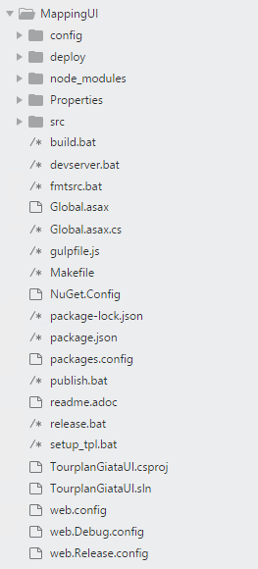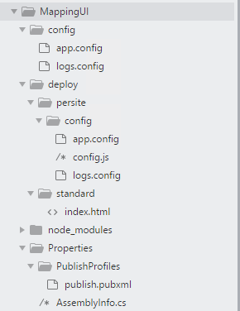

Src

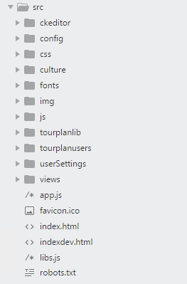

Src/css

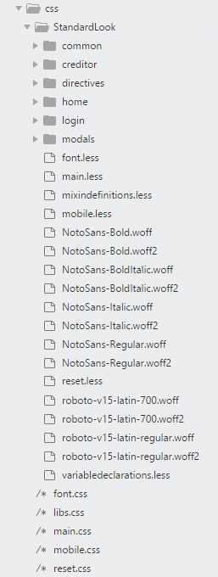

Src/Views

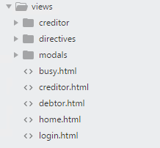

Src/js

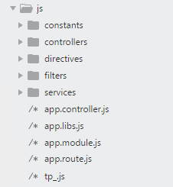

Src/tourplanlib

